Spring Security Flow

Big idea (one line)
User sends request → Security checks identity → Security remembers user → Request goes to controller
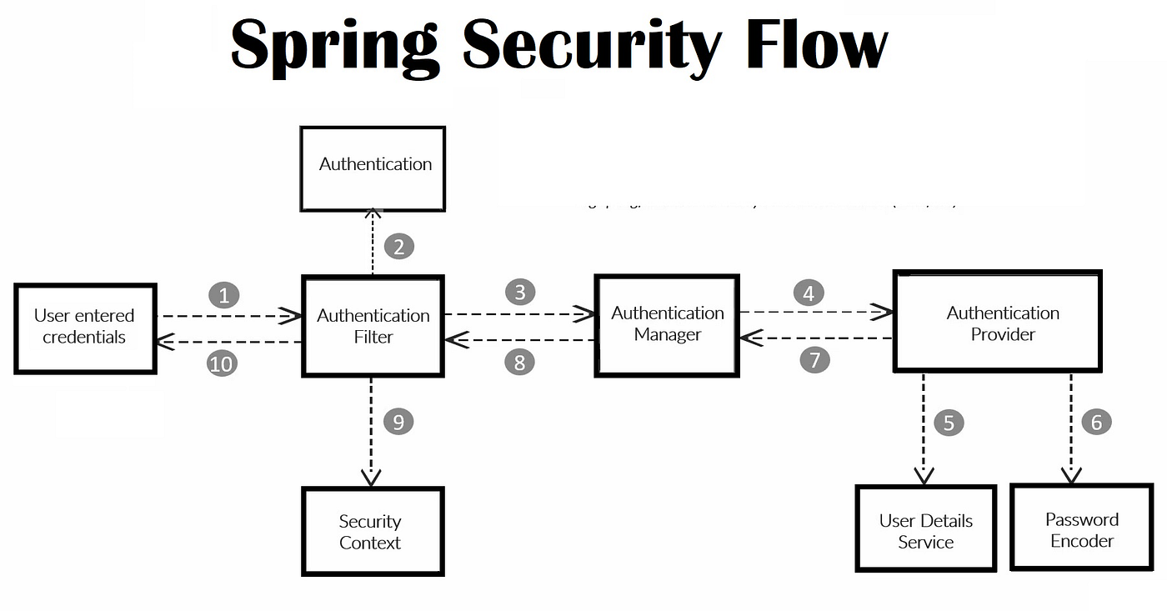

Step 1: User sends credentials
- User sends username + password (or token)
- This is just a normal HTTP request
- Spring does not know the user yet

Step 2: Spring Security Filters stop the request
- Request first hits Spring Security Filters
- Controller is not called yet
- Filters decide:
“Do I need to check login?”
Think of filters as security gate.

Step 3: Filters create an Authentication object
- Filters put username/password into an Authentication object
- Then filters say:
“Please authenticate this user”

Step 4: Filters call AuthenticationManager (AM)
- Filters send Authentication object to AuthenticationManager
- AuthenticationManager does not check password itself
- It only decides who should check

Step 5: AuthenticationManager talks to AuthenticationProviders (AP)
- There can be many AuthenticationProviders
- Example:
  - Username/password provider
  - JWT provider
- AuthenticationManager asks providers one by one:
“Can you handle this login?”

Step 6: Correct AuthenticationProvider is chosen
- The provider that understands this login type is chosen
- For username/password → DaoAuthenticationProvider
Only one provider does the real work.

Step 7: AuthenticationProvider loads user
- Provider calls UserDetailsService
- UserDetailsService loads user from:
  - Database
  - Memory
- If user not found → login fails

Step 8: PasswordEncoder checks password
- Provider asks PasswordEncoder:
  - Does input password match stored password?
- If no → login fails
- If yes → login success

Step 9: User is stored in SecurityContext
- Spring saves authenticated user in SecurityContext
- SecurityContext is stored in ThreadLocal
- Means:
  - One request = one user
  - Users never mix
- Now user is available in:
  - Controller
  - Service layer

Step 10: Request goes back to Filters → then Controller
- Filters see user is authenticated
- Authorization is checked (roles)
- If allowed → Controller method runs
- If not allowed → 403 error

Very important points (teach this)
- Controller is last, not first
- AuthenticationManager is a selector, not a checker
- AuthenticationProvider does real authentication
- UserDetailsService only loads user
- PasswordEncoder only matches password
- SecurityContext stores user per request

One perfect sentence
Spring Security first checks who the user is, remembers the user for this request, and only then allows the controller to run.

Spring Security Filters (Typical Order – Boot 3.5.x)
Spring Security internally runs multiple filters in a chain. The exact filters and their order are internal and may change, so we configure behavior instead of relying on filter names.

3 most important filters (if you MUST remember only 3)
Filter | Why
UsernamePasswordAuthenticationFilter | Login happens here
ExceptionTranslationFilter | 401 / 403 handling
AuthorizationFilter | Final access decision
Everything else is support work.

(Boot 3.5.x – Typical Order)
Order | Filter Name | What it does (simple) | Heuristic (remember like this)
1 | SecurityContextHolderFilter | Creates and clears SecurityContext for request | “Start & end user memory”
2 | HeaderWriterFilter | Adds security headers to response | “Add safety headers”
3 | CorsFilter | Handles CORS checks | “Cross-origin gate”
4 | CsrfFilter | Checks CSRF token (browser apps) | “Browser attack protection”
5 | LogoutFilter | Handles /logout request | “Logout cleaner”
6 | UsernamePasswordAuthenticationFilter | Handles username + password login | “Login filter”
7 | DefaultLoginPageGeneratingFilter | Shows default login page | “Spring auto login UI”
8 | DefaultLogoutPageGeneratingFilter | Shows default logout page | “Spring auto logout UI”
9 | RequestCacheFilter | Saves original request before login | “Remember where user came from”
10 | SecurityContextHolderAwareRequestFilter | Adds security info to request object | “Expose user to request”
11 | AnonymousAuthenticationFilter | Sets anonymous user if not logged in | “Nobody is still somebody”
12 | ExceptionTranslationFilter | Converts security errors to 401/403 | “Security error handler”
13 | AuthorizationFilter | Checks roles/permissions | “Final allow or deny”

1️⃣ SecurityContextHolderFilter
- Prepares and clears SecurityContext
- Uses ThreadLocal
- Runs very early

2️⃣ HeaderWriterFilter
- Adds security headers
- Example: X-Frame-Options, X-Content-Type-Options

3️⃣ CsrfFilter
- Protects against CSRF
- Often disabled in REST/JWT apps

4️⃣ LogoutFilter
- Handles /logout
- Clears security context

5️⃣ UsernamePasswordAuthenticationFilter
- Handles login with username/password
- Creates Authentication object
- Calls AuthenticationManager
(For JWT apps, this filter is usually bypassed)

6️⃣ DefaultLoginPageGeneratingFilter
- Generates default login page
- Only present if form login is enabled

7️⃣ DefaultLogoutPageGeneratingFilter
- Generates default logout page
- Optional

8️⃣ RequestCacheFilter
- Saves original request
- Used mainly for browser redirects

9️⃣ SecurityContextHolderAwareRequestFilter
- Wraps request
- Enables methods like getUserPrincipal()

🔟 AnonymousAuthenticationFilter
- Sets anonymous user if no authentication exists
- Prevents null authentication

1️⃣1️⃣ ExceptionTranslationFilter
- Converts security exceptions into:
  - 401
  - 403
- Calls AuthenticationEntryPoint or AccessDeniedHandler

1️⃣2️⃣ AuthorizationFilter
- Final authorization check
- Checks roles / authorities
- Decides allow or deny

Very important notes (read carefully)
- Order may change between versions
- Some filters are skipped based on config
- JWT apps add:
  - Your custom JWT filter (usually before UsernamePasswordAuthenticationFilter)
- CSRF, login page filters may not exist

Simplest possible way to plug a filter just after UsernamePasswordAuthenticationFilter,
Only for teaching / understanding. No heavy logic. Just proof that filter runs.

UsernamePasswordAuthenticationFilter only creates the Authentication object; it does not authenticate the user.

Step 1: Create a filter
public class AfterLoginDemoFilter extends OncePerRequestFilter {

@Override
protected void doFilterInternal(
HttpServletRequest request,
HttpServletResponse response,
FilterChain filterChain)
throws ServletException, IOException {

System.out.println(">>> After UsernamePasswordAuthenticationFilter");

filterChain.doFilter(request, response);
}
}

Step 2: Register this filter in SecurityFilterChain
You already have this config.
Just add one line.

🔑 Important method
addFilterAfter()

Updated config (minimal change)
@Bean
public SecurityFilterChain securityFilterChain(HttpSecurity http) throws Exception {

http.csrf(AbstractHttpConfigurer::disable)
.cors(AbstractHttpConfigurer::disable)
.authorizeHttpRequests(registry ->
registry.requestMatchers("/admin/**").hasAnyRole("ADMIN")
.requestMatchers("/mgr/**").hasAnyRole("ADMIN","MGR")
.requestMatchers("/clerk/**").hasAnyRole("ADMIN","MGR","CLERK")
.requestMatchers("/home/**").permitAll()
.anyRequest().authenticated()
)
.httpBasic(Customizer.withDefaults())
.addFilterAfter(
new AfterLoginDemoFilter(),
UsernamePasswordAuthenticationFilter.class
)
.sessionManagement(session ->
session.sessionCreationPolicy(SessionCreationPolicy.STATELESS)
);

return http.build();
}

